Online Appendix For: The Double-Edged Sword of Recombination in Breakthrough Innovation. Sarah Kaplan & Keyvan Vakili. Strategic Management Journal.

In this online appendix, we present some additional details on the topic modeling methodology used in “The Double-Edged Sword of Recombination.” A good overview of the approach can be found in Blei (2012) and more technical details in Ramage et al (2009) and McFarland et al (2013).
Latent Dirichlet Allocation algorithm

The topic modeling approach used in our paper is based on a Bayesian statistical technique called Latent Dirichlet Allocation (LDA). The core idea behind the LDA algorithm is described in the section ‘A primer on topic modeling’ in the accompanying article. Also, Figure 2 in the paper illustrates a schematic representation of the relationship between the various elements in the algorithm, including topics, words, and documents. This section describes the fundamental mathematical model behind the LDA algorithm.
Let 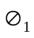,…, 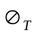 be topics. Each topic is a distribution over a fixed set of terms. The Latent Dirichlet Allocation (LDA) method assumes each document has its own set of topic proportions , but the whole corpus is governed by the same set of latent topics 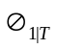. In other words, for each document in the corpus, LDA assumes the following generative probabilistic process:
Choose , topic proportions Dirichlet(α)
- For each term:
Choose a topic assignment 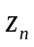 Multinomial()
Choose term 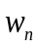 from 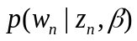, a multinomial probability conditioned on the topic assignment from the previous step.
is a -dimensional Dirichlet random variable with values in the (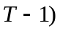-simplex and the following probability density:
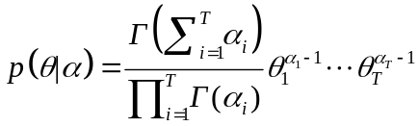
where 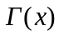 is the Gamma function and is a vector with components 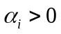. The Dirichlet distribution over the simplex is in the exponential family and has convenient properties that facilitate the process of inference and parameter estimation.
With parameters and as given, the joint distribution of the set of  words , the set of topic assignments , and the topic proportions is as follows:
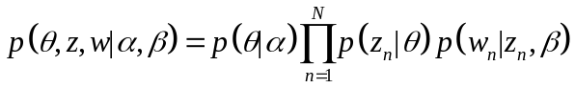
where 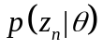 is equal to 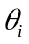 for the unique at which 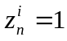. The marginal distribution of a document can then be calculated by integrating over and summing over :
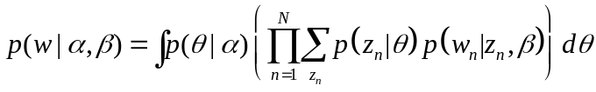
Now we can calculate the probability distribution of a corpus by taking the product of the marginal probabilities of all the single documents in the corpus:
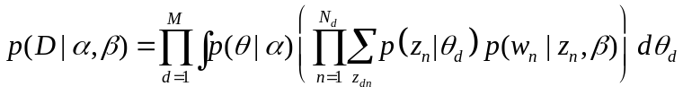
The central problem in LDA is to calculate the conditional distribution of the unobserved variables: topics (), topic proportions , and topic assignments . The set of these hidden variables is called posterior. There are several algorithms proposed to estimate the posterior. The standard approach uses a Gibbs sampling, in which a Markov chain – a sequence of random variables each dependent on the previous one – with a limiting distribution converging to the posterior is constructed. The algorithm runs a series of Markov chains defined based on the hidden variables, collects samples from the limiting distributions, and calculates an approximation for the distribution based on the collected samples. See Steyvers and Griffiths (2006) for an elaborated description of the Gibbs sampling and the estimation method. Also see Ramage et al. (2009) and McFarland et al. (2013) for more details on the LDA algorithm.

Input parameters for topic modeling analysis

The goal of topic modeling techniques as developed in the computer sciences is unsupervised analysis of text designed both to generate a predictive model to aid search and to provide a representation of the topics in an existing corpus (Hall et al. 2008; Chang et al. 2009). In our paper, we focus on this second goal, and we use our data to track the emergence of new ideas (and hence new language to describe these ideas) over time and identify the patents that lead to these shifts in language. In the five sections under the header ‘Topic modeling of patent texts: a measure of novel ideas’ in the paper, we delineate the topic modeling technique and how we use it to identify the patents that originate new topics. In this section, we describe the specific set of parameters that are required for topic modeling analysis and our particular choices for the analyses reported in the paper.

All topic-modeling techniques require a text corpus as input. Our input corpus comprises the abstracts of 2,384 patent families based on the 2,826 fullerene and nanotube patents. The process of identifying the fullerene patents and patent families are explained in the ‘Deriving fullerene and nanotube topics’ section in the paper.

Furthermore, the LDA algorithm requires inputs for two specific parameters: α (sometimes called ‘topic smoothing’) and β (sometimes called ‘term smoothing’). Values above one lead to more even distributions. Values below one favor more concentrated distributions across fewer topics or words. In order to produce semantically meaningful topics, most topic modeling toolkits (including the ‘Stanford Topic Modeling Toolbox’ that we used) recommend 0.1 for both parameters as a default. As a smaller β results in more fine-grained topics (Griffiths & Steyvers, 2004), we lowered this parameter to 0.01 because we are studying a narrow field of technology. The algorithm thus allocates documents to the fewest topics possible while at the same time assigning a high probability to as few words as possible for each topic.
The algorithm also requires input for the number of topics that it would produce at the end. There are a few methods to optimize the number of topics to achieve a best-fit outcome. However, such best-fit models often produce a large number of topics that do not represent distinct meanings (Chang et al. 2009). Hence, following the approach by computer science scholars (Blei & Lafferty 2007; Hall et al 2008), we capped our model to 100 topics. The section ‘Deriving fullerene and nanotube topics’ in the paper describes the process of extracting, labeling, and validating the topics.
Figure A1 shows a sample abstract and the weight of its most important topics. Patent number 7288970 ‘Integrated nanotube and field effect switching device’ is dominated by topic 24 (‘Nanotube switching devices and applications’) with 63 percent weight and topics 54 (‘Electronic implementations of look up tables’) and 49 (‘Field emissions display devices’) each with 5 percent weight. No other topic is greater than 5 percent weight. The sum of the weights of all the topics for any given patent is 100 percent. Figure A2 provides graphical representations of sample topics with the top 20 words associated with each sized in proportion to their importance.

Figure A1: Example coded abstract
Patent Number: US7288970
Title: Integrated nanotube and field effect switching device
Inventors: Bertin, Claude L.
Assignee: Nantero, Inc.
Application Date: January 2005, Issue Date: October 2007
USPTO classifications: 326/120, 326/112, 977/940

Abstract
Hybrid⁵⁷ switching²⁴ devices³² integrate⁵⁴ nanotube⁵⁶ switching²⁴ elements²⁵ with field⁴⁹ effect⁵² devices³², such as NFETs and PFETs. A switching²⁴ device⁹³ forms⁴⁶ and unforms²⁴ a conductive⁵⁹ channel⁵² from the signal²⁴ input²⁴ to the output²⁴ subject²² to the relative⁸⁶ state of the control²⁴ input²⁴. In embodiments⁹⁴ of the invention, the conductive⁵⁹ channel⁵² includes a nanotube⁵⁶ channel⁵² element²⁵ and a field⁴⁹ modulatable⁵⁸ semiconductor⁴⁶ channel⁵² element²⁵. The switching²⁴ device⁹³ may include a nanotube⁵⁶ switching²⁴ element²⁵ and a field⁴⁹ effect⁵² device⁹³ electrically⁵⁹ disposed⁴² in series²⁴. According to one aspect³³ of the invention, an integrated⁵⁴ switching²⁴ device⁹³ is a four-terminal²⁹ device⁹³ with a signal²⁴ input²⁴ terminal⁴², a control²⁴ input²⁴ terminal²⁹, a second input²⁴ terminal²⁹, and an output²⁴ terminal²⁹. The devices³² may be non-volatile²⁴. The devices³² can form²⁴ the basis for a hybrid⁵⁷ NT-FET⁵² logic⁵⁴ family and can be used to implement⁸² any Boolean logic⁵⁴ circuit⁵⁴.

Topic 24 (Nanotube switching devices and applications): 63%
Topic 54 (Electronic implementations of look-up-tables): 5%
Topic 49 (Field emissions display devices): 5%
The rest: less than 5% each for a total of 27%

Figure A2: Graphical representation of words in example topics
Topic 14: Sensors and detectors  (1993) | Topic 60: Application to batteries and charge storage devices (1998)
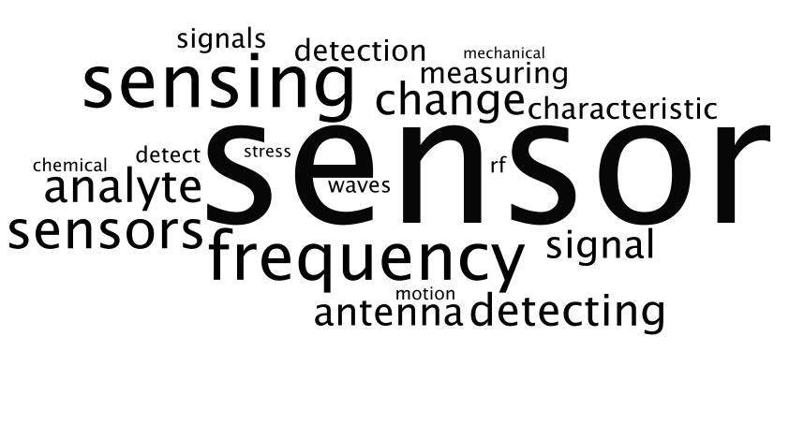 | 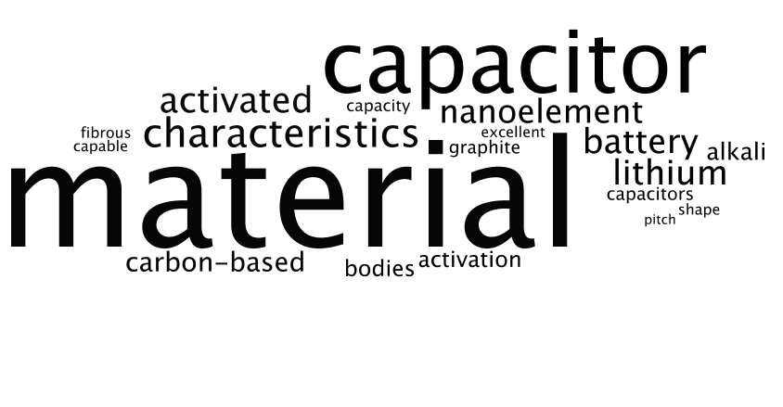
Topic 58: Application to plasma display panels  (1997) | Topic 24: Nanotube switching devices  (2004)
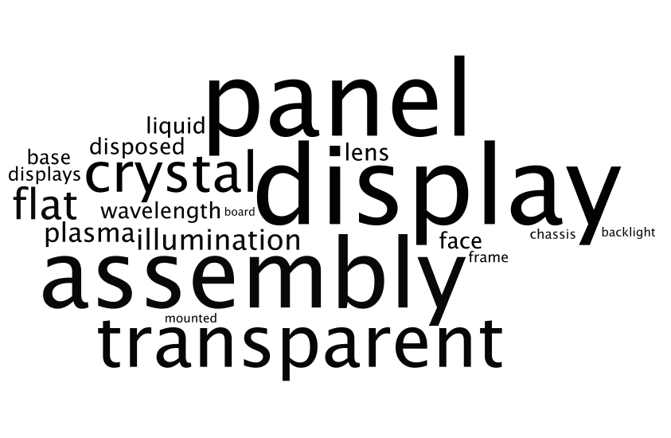 | 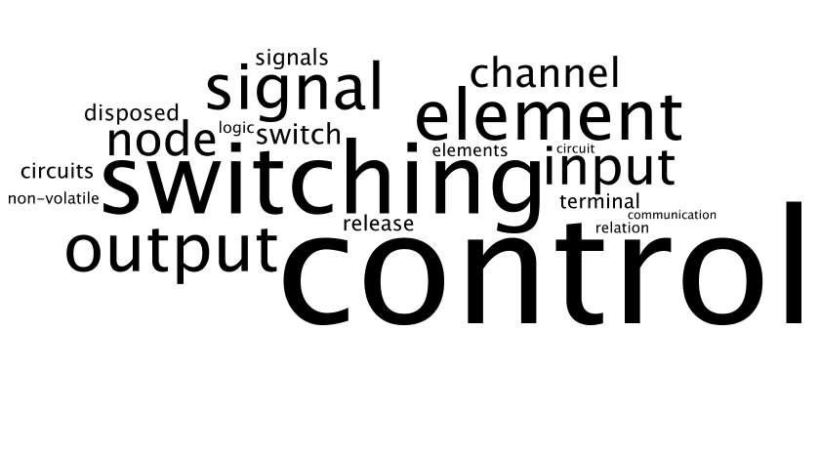
Note: date of topic-originating patent in parentheses. Size of words based on importance.

Checking the validity of the topic selection process
We used three expert coders to validate and label the topics. The coders found 25 topics to be very general and therefore difficult to label with distinctive codes. This is not surprising as topic models tend to place noisy data into broad or uninterpretable topics (which serves to bolster the coherence of the other topics). We performed the statistical analyses reported in the paper omitting these general topics and found fully consistent results. However, since our interest is in introducing a replicable approach using unsupervised analysis of texts, in the paper we only report the results based on all 100 topics rather than the results that depend on human intervention by coders.
As explained in the paper, we use a threshold for topic weight to identify the first patents that represent each topic. In the paper, we explain the details of how we chose the threshold in the section ‘Deriving fullerene and nanotube topics.’ For robustness tests, we also explored other methodologies for identifying topic-originating patents, such as selecting the first patent to represent a substantial jump in weight relative to prior patents. For example, if we look at patents that represent a 3 standard deviation jump from prior patents and all subsequent patents over that weight in the first year, we obtain a list of 141 patents, of which 73% are the same as those topic-originating patents identified using our 0.2 threshold. The results using this alternative measure are substantially the same as those we report in the paper. Note, however, that in every case, the selection of a topic-originating patent requires an assumption about a threshold, whether it is a weight of 0.2 or a number of standard deviations. Therefore, we prefer to use the threshold that has been validated by coders.

References
Blei DM. 2012. Probabilistic topic models. Communications of the ACM 55(4): 77-84.
Blei DM, Lafferty JD. 2007. A Correlated Topic Model of Science. Annals of Applied Statistics 1(2): 634-634.
Chang J, Boyd-Graber J, Wang C, Gerrish S, Blei D. 2009. Reading Tea Leaves: How Humans Interpret Topic Models. In Proceedings of Neutral Information Processing Systems. Available at: http://goo.gl/QzeEv9.
Griffiths TL, Steyvers M. 2004. Finding Scientific Topics. Proceedings of the National Academy of Sciences 101: 5228-5235.
Hall D, Jurafsky D, Manning CD. 2008, Studying the Histories of Ideas Using Topic Models. In Proceedings of The Conference on Empirical Methods in Natural Language Processing. Avilable at: http://dl.acm.org/citation.cfm?id=1613763.
McFarland DA, Ramage D, Chuang J, Heer J, Manning CD, Jurafsky D. 2013. Differentiating language usage through topic models. Poetics 41(6): 607-625.
Ramage D, Rosen E, Chuang J, Manning C, McFarland DA. 2009. Topic Modeling for the Social Sciences. In NIPS 2009 Workshop on Applications for Topic Models: Text and Beyond .
Steyvers, M, Griffiths T. 2006. Probabilistic topic models. In Handbook of latent semantic analysis, Landauer T, McNamara D, Dennis S, Kintsch W (eds). Lawrence Erlbaum: Mahwah, NJ: 427-448.

